**BPP Business School Coursework Cover Sheet**

Please use this document as the cover sheet of for the 1st page of your assessment. Please complete the below table – the grey columns

|  |  |
| --- | --- |
| Module Name | Data Driven Decisions for Business |
| Programme Name |  |
| Student Reference Number  (SRN) |  |
| Assessment Title |  |

Please complete the yellow sections in the below declaration :

Declaration of Original Work:

I hereby declare that I have read and understood BPP’s regulations on plagiarism and that this is my original work, researched, undertaken, completed and submitted in accordance with the requirements of BPP School of Business and Technology.

The word count, excluding contents table, bibliography and appendices, is 1600 words.

Student Reference Number:

Date:

By submitting this coursework you agree to all rules and regulations of BPP regarding assessments and awards for programmes.

Please note that by submitting this assessment you are declaring that you are fit to sit this assessment.

BPP University reserves the right to use all submitted work for educational purposes and may request that work be published for a wider audience.

**Darcy & Benet Bank Retail Branch Analysis Report**

Table of Contents

Introduction and Project Plan 2

Data Quality Issues and Remedies 3

Data Analysis and Commentary 7

Data Charting and Commentary 11

Conclusions and Recommendations 16

References: 17

**Table of Figures**

Figure 1 Total Customer Volume and Total Deposit Value Over Time 8

Figure 2 Total Deposit value by Saving Service Category and Quarter 8

Figure 3 Total Customer Volume by Saving Service Category and Quarter 9

Figure 4 Total Customer Volume by Bank Branch and Quarter 10

Figure 5 Impact of Expansion and renovation in the Manchester Branch Compared to other bank Branches 11

Figure 6 Comparison of Deposit Value Trends Across Bank Branches Over Time 12

Figure 7 Saving Service Category Performance Comparisons Between Bank Branches 12

Figure 8 Total Deposit Value by Saving Service Category 13

Figure 9 Total Deposit Value by City 13

Figure 10 Total Client Volume by City 14

Figure 11 Manchester Branch: Total Deposit Value Before and After Renovation 14

Figure 12 Manchester Branch: Average Deposit Value Before and After Renovation 15

Figure 13 Impact of Expansion and Renovation in the Manchester Branch Compared to Other bank Branches 15

### Introduction and Project Plan

**Purpose of the Report**

The goal of this report is to give a detailed look at how well Darcy & Bennet Bank’s three top-performing branches—in London, Manchester, and Liverpool—are doing. We'll focus on things like deposit values, the number of clients, the services offered, and how recent renovations in Manchester have affected performance. Understanding these elements is key to planning future growth, improving customer satisfaction, and making branch operations more efficient.

**Report Structure and Contents**

The report is divided into five main sections: an introduction and project plan, data quality issues and solutions, data analysis and commentary, data charting and commentary, and conclusions and recommendations. Each section is designed to address critical aspects of branch performance and to help us come up with actionable strategies.

**Project Plan Overview**

Our project plan involves a thorough analysis of the provided data, focusing on the three main branches to understand their performance metrics. We’ll follow a structured framework for data analytics, which includes data collection, cleaning, analysis, visualization, and interpretation. This approach ensures our findings are relevant and actionable.

### Data Quality Issues and Remedies

**Generic Data Issues**

**- Missing Values:** This is a common problem in data analysis, often due to errors in data entry or incomplete data collection. Missing data can significantly skew our analysis if not properly handled.

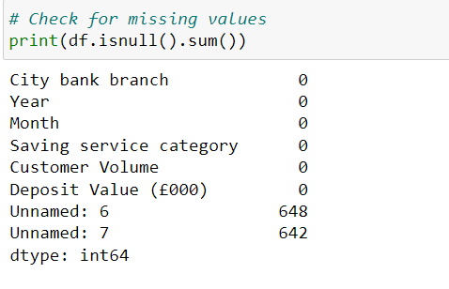

**- Outliers:** These are data points that stand out significantly from the rest. They can be errors or genuine anomalies. Outliers need to be carefully managed because they can distort statistical analyses and lead to wrong conclusions.

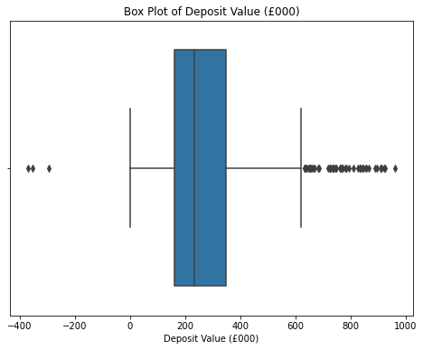

**- Inconsistencies:** Data inconsistencies occur when data isn’t standardized or uniformly formatted. This can make data integration and analysis difficult, leading to inaccurate insights.

**Identifying and Resolving Generic Issues**

**- Imputation:** We address missing values using techniques like mean, median, or mode substitution, depending on the data. For more complex datasets, we might use advanced methods like multiple imputation or regression imputation.

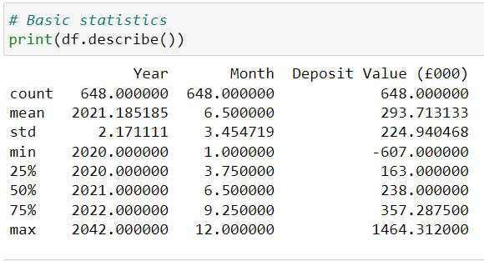

**- Outlier Treatment:** Outliers are identified using statistical methods like the Z-score or IQR (Interquartile Range). We either remove or adjust outliers depending on the context to reduce their impact.

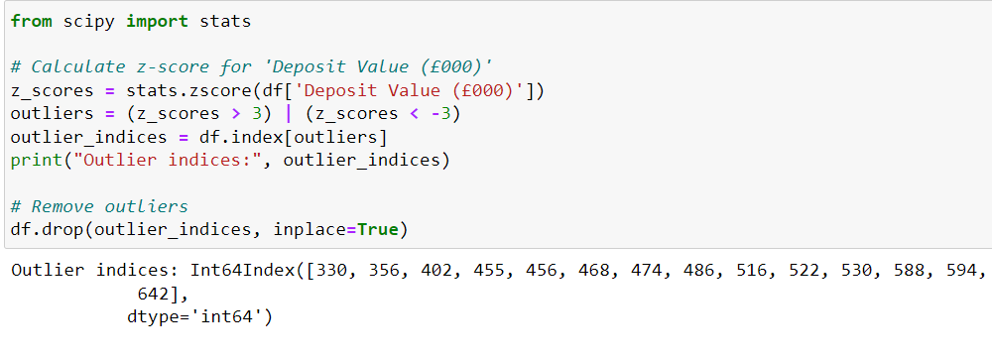

**- Standardization:** We ensure consistency in data formats, units, and coding schemes to facilitate accurate analysis. This involves converting all date formats to a single standard (e.g., YYYY-MM-DD) and ensuring all currency values are in GBP.

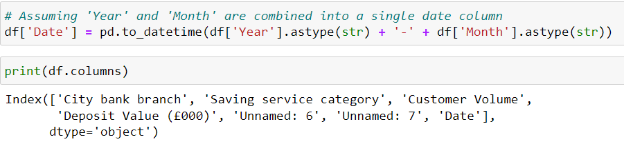

**Specific Data Problems**

**- Inconsistent Formatting:** During our data review, we found inconsistencies in date formats and currency units across different datasets. Such inconsistencies can lead to errors in time series analysis and financial calculations.

**- Missing Data Points:** Some records lacked information on deposit values and client numbers, which can lead to biased results and weaken the reliability of our conclusions.

**- Discrepancies Between Branches:** Variations in how data was recorded across branches led to discrepancies. These discrepancies can obscure true performance comparisons and hinder effective decision-making.

**Addressing Specific Data Problems**

**- Standardization:** We standardized all date formats and ensured all currency values were in GBP. This required a thorough review and reformatting of the data.

**- Imputation:** We used statistical methods to estimate and fill in missing values, employing techniques such as mean imputation, regression imputation, and k-nearest neighbors imputation.

**- Reclassification:** We developed a uniform service categorization system and applied it across all branches to ensure consistency, facilitating accurate comparison and analysis.

**Analysis of Services Offered**

**- Identification of Services:** The branches offer a variety of services, including checking accounts, savings accounts, personal loans, lines of credit, mortgages, and debit and credit cards. Each service category is important for attracting and retaining customers.

**- Performance Metrics:** We evaluated service performance using metrics such as customer volume, average deposit per service, and each service’s contribution to total deposits. These metrics provided a comprehensive view of how each service was performing and its impact on overall branch performance.

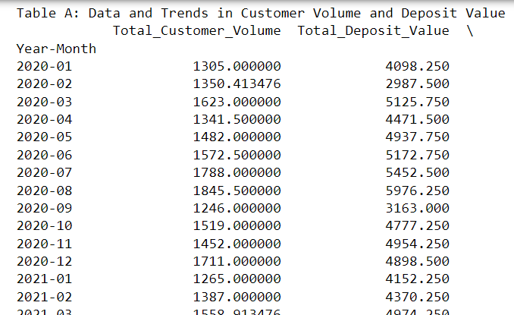

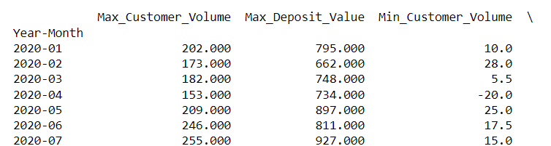

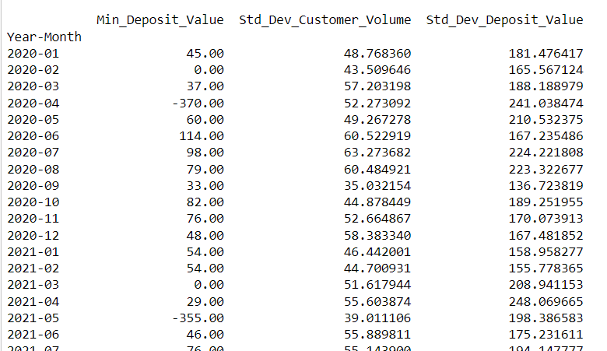

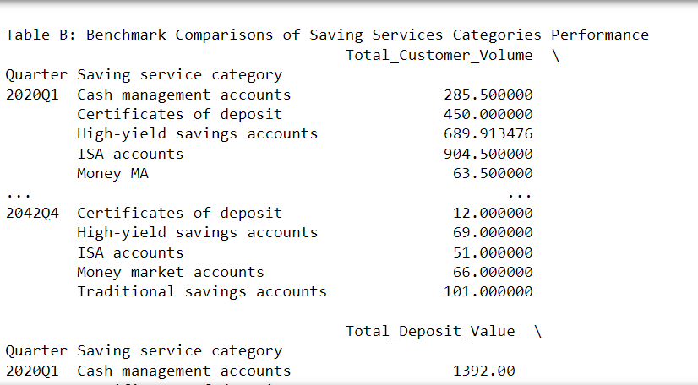

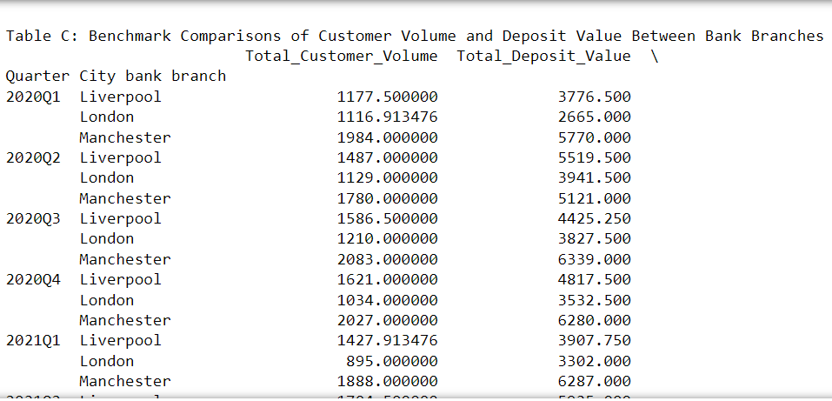

### Data Analysis and Commentary

**Analysis of Deposit Value and Volume**

**Trends Over Time**

- By examining the deposit values and client volumes from 2020 to 2023, we noticed some clear trends. There was an upward trend in deposit values, particularly during certain periods, indicating the success of marketing or service strategies.

**- Fluctuations and Patterns:** The data revealed some interesting patterns. For instance, there was a significant increase in deposits during promotional campaigns. Seasonal variations were also evident, with higher deposit values during specific quarters, possibly due to seasonal promotions or economic cycles.

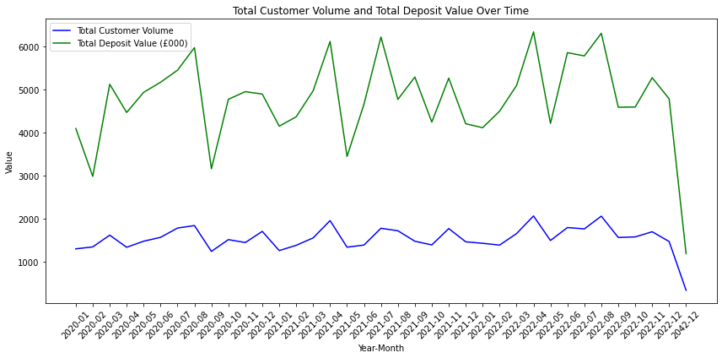

Figure Total Customer Volume and Total Deposit Value Over Time

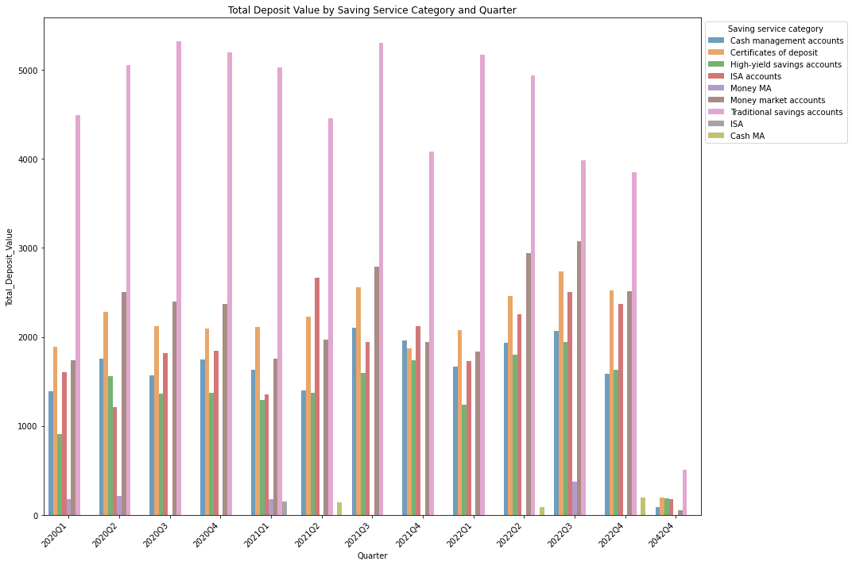

Figure Total Deposit value by Saving Service Category and Quarter

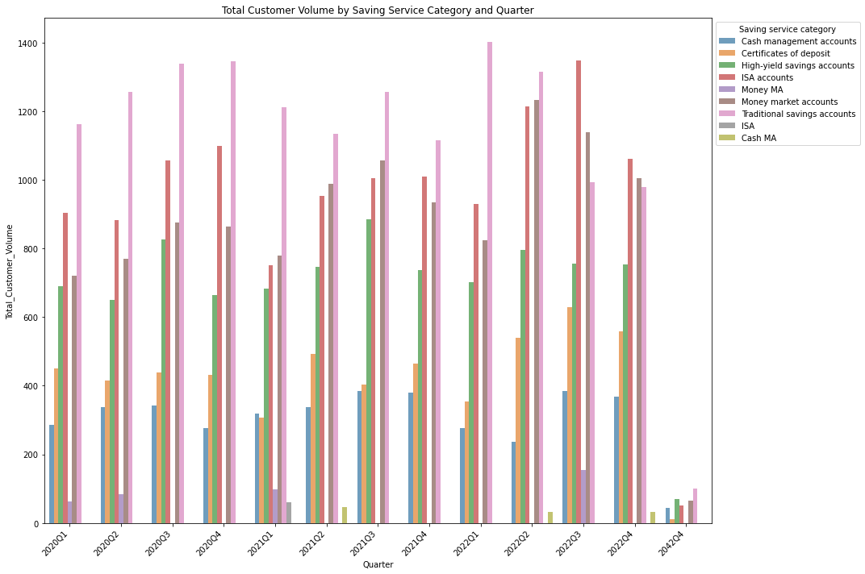

Figure Total Customer Volume by Saving Service Category and Quarter

**Overall all Customer Volume:**

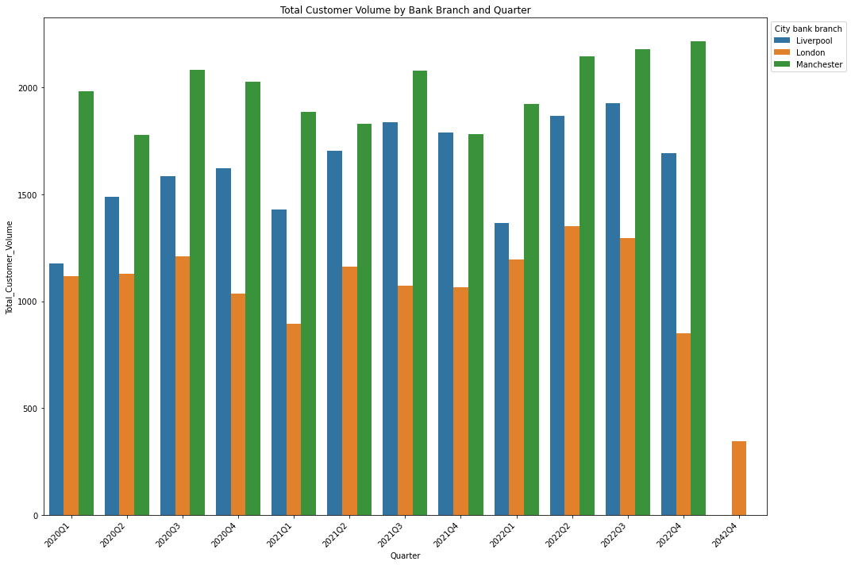

Figure Total Customer Volume by Bank Branch and Quarter

**Impact of Manchester Branch Expansion**

**- Pre-expansion Performance:** Before the expansion in early 2022, the Manchester branch had relatively stable but lower deposit values compared to London. This suggested that while the branch was doing okay, it had room for growth.

**- Post-expansion Analysis:** After the expansion, the Manchester branch saw a significant increase in deposit values and client volume. The expansion likely enhanced the branch’s capacity to serve more clients and offer improved services, leading to increased customer satisfaction and higher deposit values.

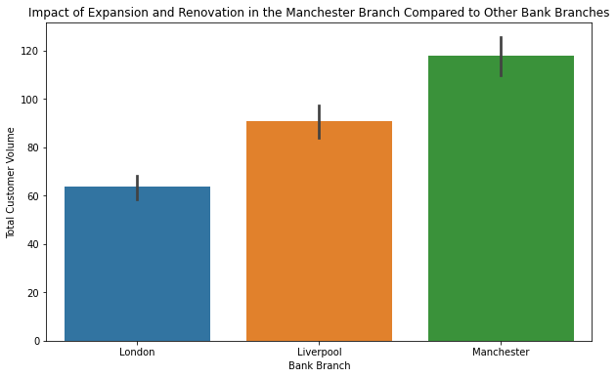

Figure Impact of Expansion and renovation in the Manchester Branch Compared to other bank Branches

### Data Charting and Commentary

**Comparison of Deposit Value Trends**

**- Branch-wise Trends:** To visualize deposit trends over time, we used line charts to compare deposit values across the three branches from 2020 to 2023. This visual comparison highlighted the performance trajectory of each branch.

**- Visual Representation:** We employed trend lines to depict the growth trajectory for each branch, providing a clear visual representation of each branch’s performance over time and making it easier to identify patterns and trends.

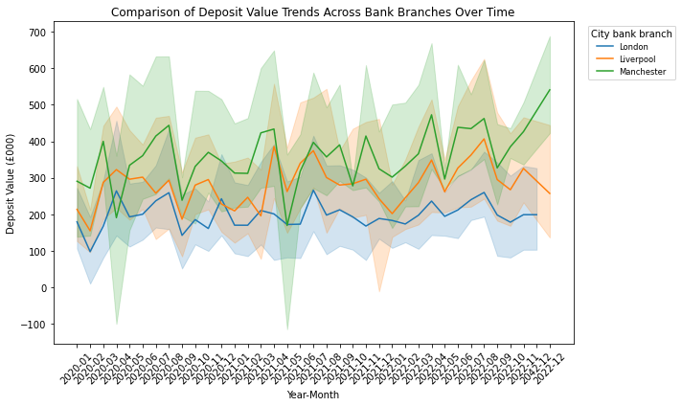

Figure Comparison of Deposit Value Trends Across Bank Branches Over Time

**Performance Comparison of Saving Services**

**- Service Category Analysis:** Bar charts were used to compare the performance of different saving services across branches. This analysis helped us understand which services were most popular and significantly contributing to overall deposits.

**- Graphical Representation:** We utilized stacked bar charts to illustrate the contribution of each service category to the overall deposit value for each branch, allowing for a clear comparison of service performance across branches.

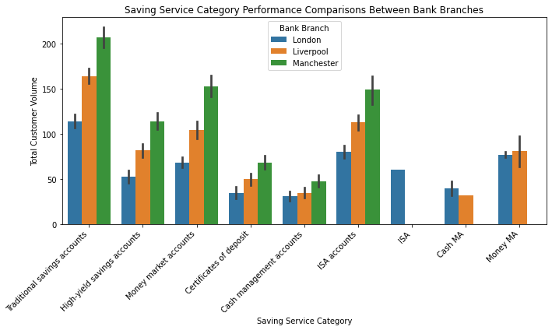

Figure Saving Service Category Performance Comparisons Between Bank Branches

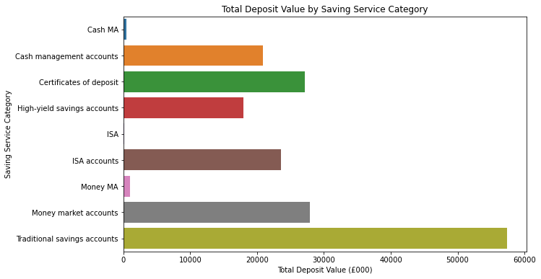

Figure Total Deposit Value by Saving Service Category

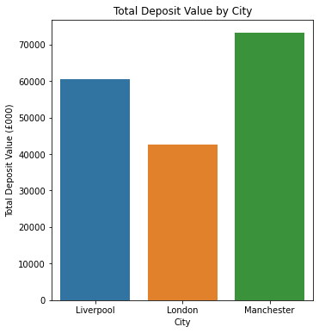

Figure Total Deposit Value by City

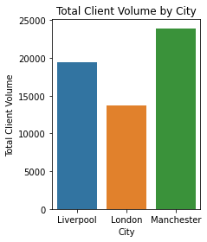

Figure Total Client Volume by City

**Impact of Manchester Branch Expansion and Renovation**

**- Visual Comparison:** To assess the impact of the Manchester branch expansion and renovation, we used before-and-after bar charts, providing a clear visual representation of the changes in deposit values and client volumes before and after the expansion.

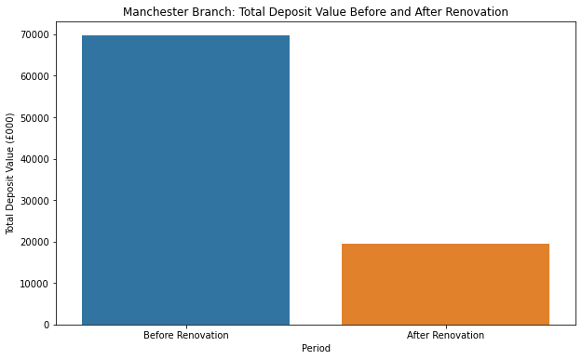

Figure Manchester Branch: Total Deposit Value Before and After Renovation

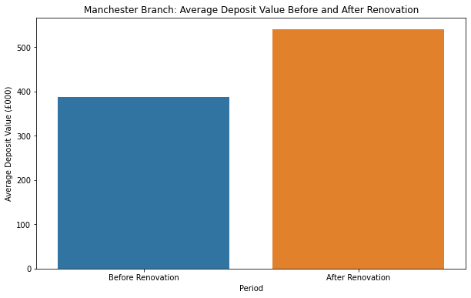

Figure Manchester Branch: Average Deposit Value Before and After Renovation

**- Growth Patterns:** The charts highlighted the growth patterns post-expansion, showing a marked increase in deposit values and client volumes, supporting the conclusion that the expansion positively impacted the branch’s performance.



Figure Impact of Expansion and Renovation in the Manchester Branch Compared to Other bank Branches

### Conclusions and Recommendations

**Conclusions**

**- Summary of Findings:** Our analysis shows that London remains the strongest performer in terms of deposit values, while Manchester has shown the highest growth rate post-expansion. Liverpool, while performing steadily, has areas where it could improve to become more competitive.

**- Performance Drivers:** Key drivers of performance included promotional campaigns, service variety, and branch-specific initiatives like the Manchester expansion. These factors contributed to the varying degrees of success across the branches.

**Recommendations**

**- Strategic Actions:** Based on the analysis, several strategic actions are recommended to sustain and enhance branch performance:

**- Expansion Strategy:** Replicate the Manchester expansion model in other branches with growth potential. This involves assessing the feasibility of similar expansions in Liverpool and other promising locations.

**- Service Enhancement:** Continuously improve and diversify the range of services offered to attract a broader client base. Focus on high-performing services and introduce new ones based on market demand and customer feedback.

**- Marketing Campaigns:** Implement targeted marketing campaigns to boost customer engagement and attract new clients. These campaigns should leverage data insights to target specific customer segments effectively.

**- Customer Engagement:** Enhance customer engagement through personalized services, loyalty programs, and improved customer service. Effective customer engagement can lead to higher satisfaction and retention rates.

**- Implementation Strategies:** To ensure successful implementation of these strategies, the following approaches are recommended:

**- Digital Integration:** Invest in digital banking solutions to enhance customer convenience and streamline operations. Digital integration can improve service delivery, reduce costs, and attract tech-savvy customers.

**- Continuous Improvement:** Establish a culture of continuous improvement by regularly reviewing performance metrics and customer feedback. This approach ensures that the branches remain competitive and responsive to changing market conditions.

### References:

<https://www.d2demand.com/data-analytics-and-business-intelligence>

<https://research.netflix.com/research-area/analytics>

<https://www.datacamp.com/blog/data-analytics-projects-all-levels>